Appendix 2

Data Collection

https://docs.google.com/forms/d/1kE-S8_C7uCa6-x6YBsTVDJ0Puu-Zxv-kiG3nDq5EfC8/viewform?usp=send_form
google docs form engine link

I have screen copied the google form as delivered below:
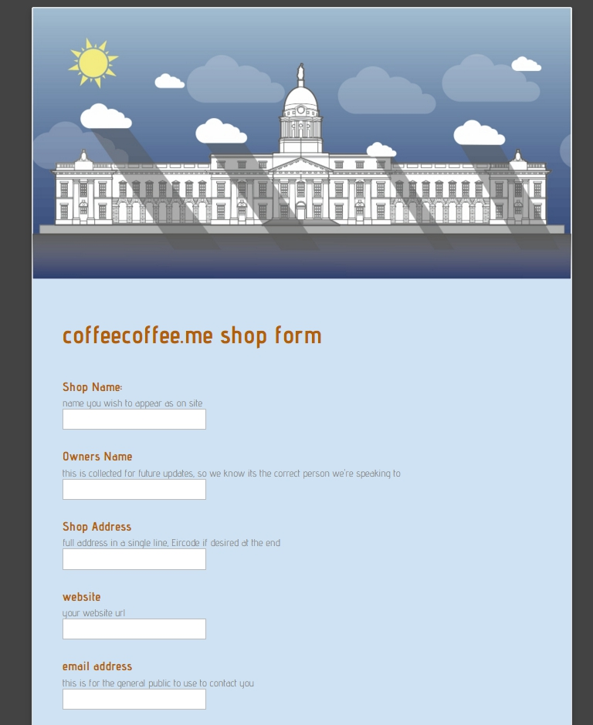
cont...
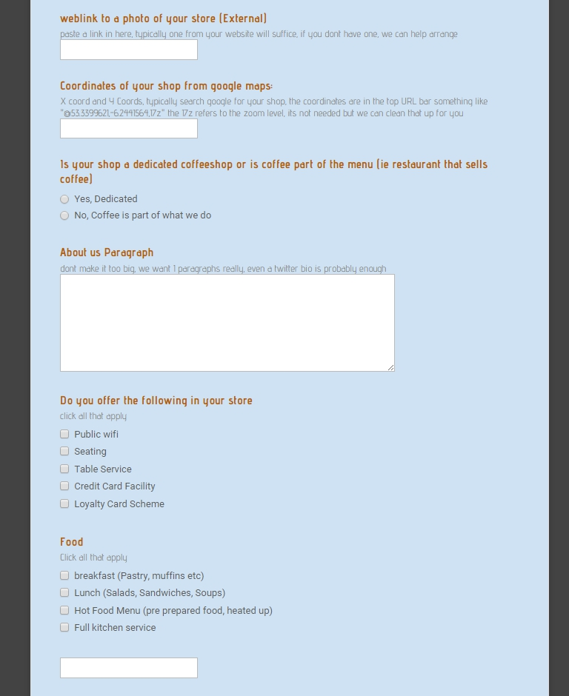
cont...

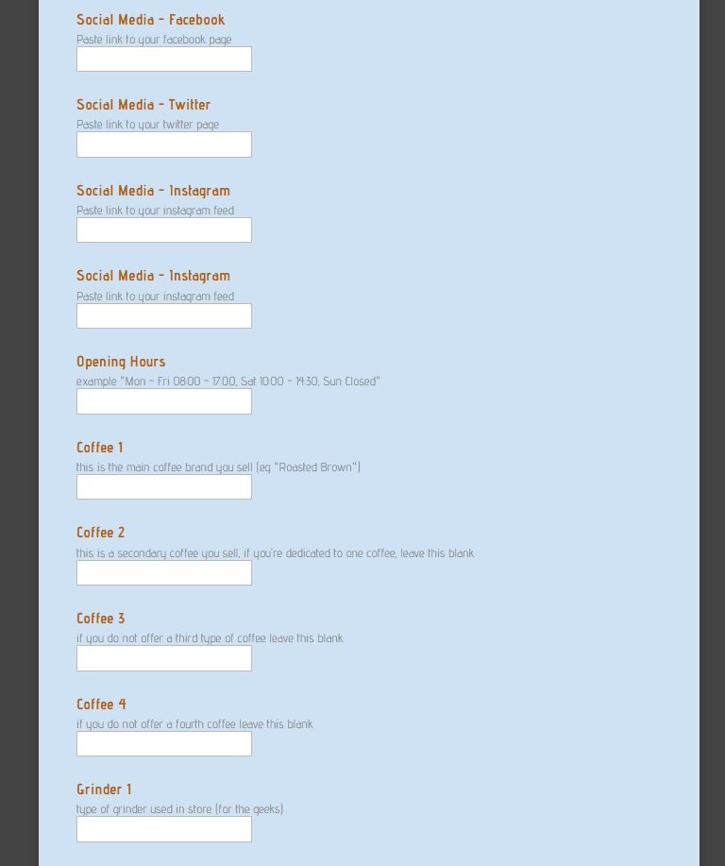
cont...

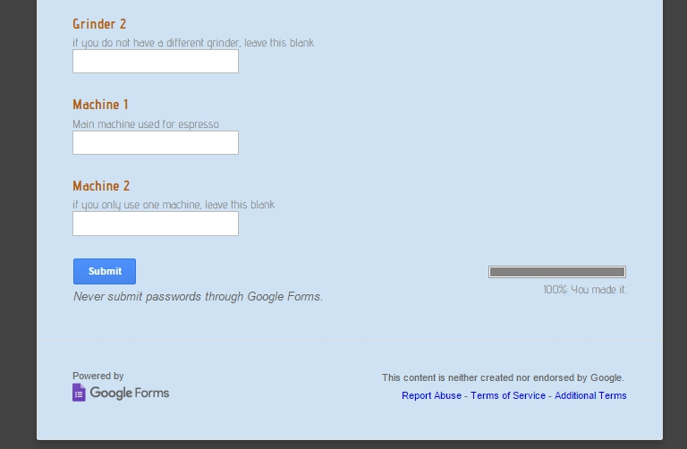
fig A.1

